When you first log into Church Center you’ll see a screen that looks like this

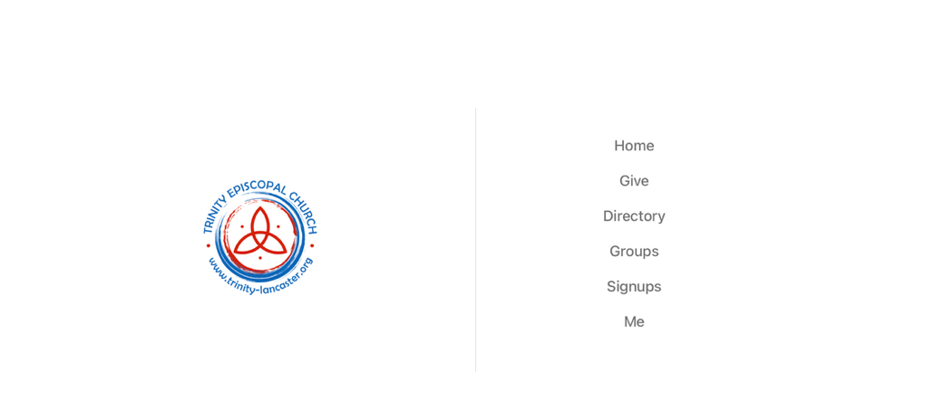
To edit your information, click on Me,
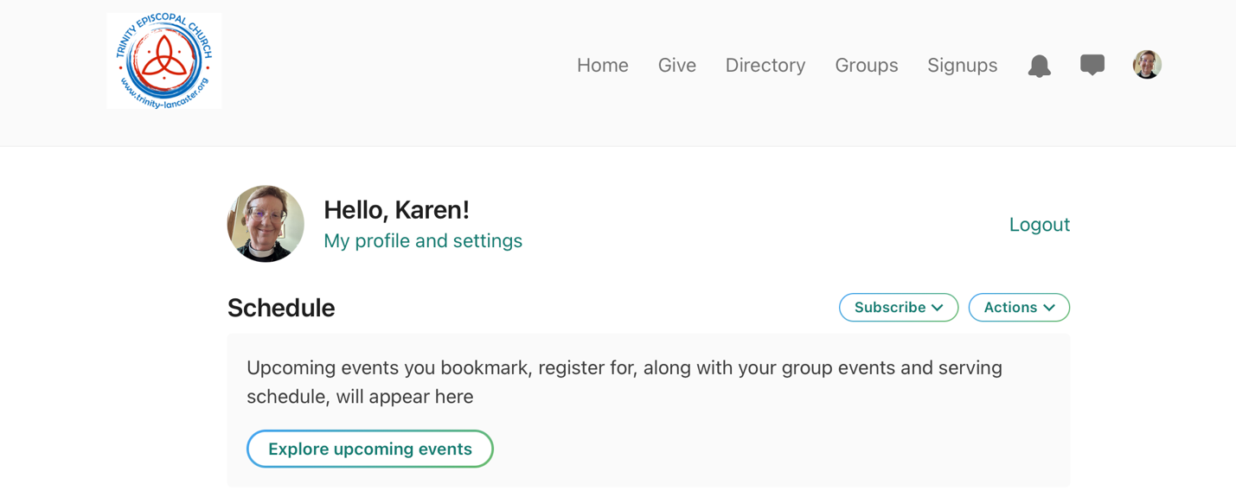
then My profile and settings. This will take you to a screen that looks like this
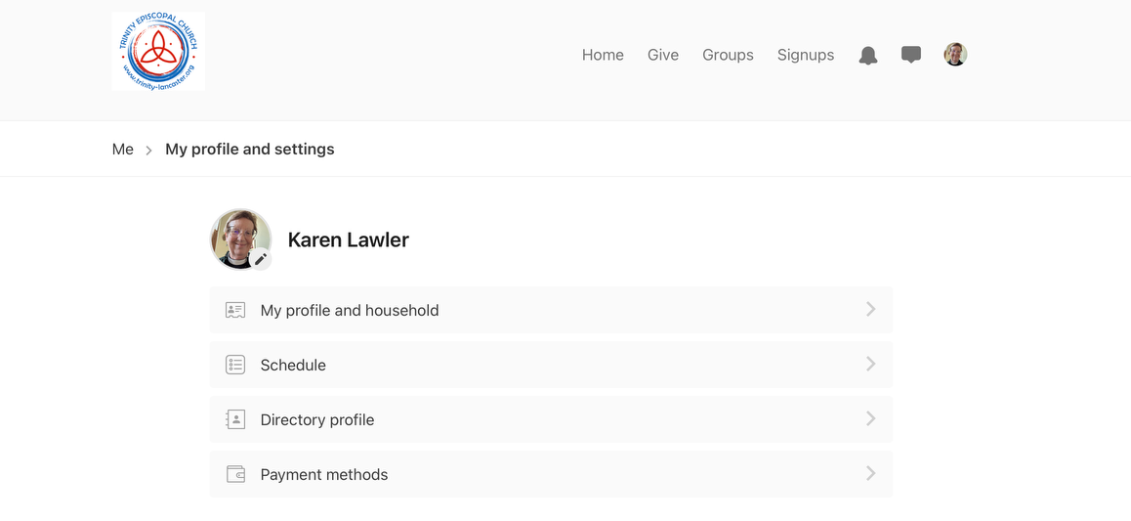
Here you can:
- add a photo by clicking on the pencil near your initials
- click on my profile and household to edit your personal information, updates phone number(s), address and more
- the + button lets you add people to your household, like a spouse who attends periodically, a younger child whose name and birthday we not have yet

Directory profile lets you decide what information you want to share with people in your church.

